# Experiment No.: 04 Alarm Annunciator

|  |  |
| --- | --- |
| **Academic Year** | **: 2021-22 Sem : I** |
| **Class** | **: TY BTech Instrumentation & Control** |
| **Course Name** | **: Process Instrumentation** |
| **Course Code** | **: IC3231** |
| **Name** | **: Shaunak Deshpande** |
| **Division** | **: IC-C** |
| **Roll No.** | **: 39** |
| **G.R. No.** | **: 11911180** |

**Experiment No.: 04**

**Alarm Annunciator**

**Aim :** Demonstration of Alarm Annunciator and deciding its specifications.

**Apparatus :** Alarm annunciator, switches, connecting wires etc.

### Theory :

The annunciator system consists of multiple individual alarm points, each connected to trouble contact (alarm switch) logic module and visual indicator. As shown in figure 1, individual alarm points are operated from common modes supply and share a number of annunciator system components including an audible signal generator, flasher acknowledge and test push buttons.

In normal operation the annunciator system and individual alarm points are quiescent. Here trouble contact is an alarm switch that monitors a particular process volume variable and is actuated when variable exceeds preset limits.

In electric annunciator system, it is normally a switch contact that closes (make) or opens (breaks) the electrical circuit to the logic module thus indicating the alarm indication in the alert condition the annunciator turns on visual indicator for the particular alarm points and activates signal as well as flasher for the system.

The visual indicator is usually back lighted nameplate engraved with an inscription to identify the variable and abnormal condition. Audible signal can be horn, a buzzer or a bell. A flasher is common to all individual alarm points and also interrupts the circuit to the visual indicator, when all the points go to alarm condition. This causes a continuous flashing of light intermittently until either the abnormal condition returns to normal or the operator acknowledges it.

The horn acknowledge push button is provided with a momentary contact when it is operated, it changes the logic module circuit to silence the audible signal and stops the flasher and turns the visual indicator steady. When abnormal condition is corrected, trouble contacts returns to normal, visual indicator is turned off when reset is pressed.

The lamp test push button with its momentary contact test for burned out lamps is the visual indicator when activated. The push button closes a common circuit to each visual indicator in annunciator system turning on a result of abnormal operating condition. The operating sequence is normal stage. The fire and most commonly used annunciator sequence are identified by the code designation of ISA.

|  |  |  |  |  |  |
| --- | --- | --- | --- | --- | --- |
| **ISA**  **CODE** | **ANNUNCIATOR**  **CONDITION** | **PROCESS**  **VARIABLE** | **VISUAL**  **INDICATOR** | **AUDIBLE**  **SIGNAL** | **USE**  **FREQ.** |
| 1B | Normal Alert  Acknowledge Normal (again) Test | Normal Abnormal Abnormal Normal  Normal | Off Flashing On  Off On | Off On Off Off  On | 55 % |
| 1D | Normal Alert  Acknowledge Normal (again) | Normal Abnormal Abnormal  Normal | Dim Flashing On  Dim | Off On Off  Off | 1 % |
| 2A | Normal Alert  Acknowledge Normal (again) Reset  Test | Normal Abnormal Abnormal Normal Normal Normal | Off Flashing On  On Off On | Off On Off Off  Off On | 5 % |
| 4A | Normal Alert  (a) Initial Subsequent Acknowledge  (a) Initial Subsequent Normal (again)  Test | Normal Abnormal  Abnormal Normal Normal | Off  Flashing On  On On Off On | Off  Off On  On On Off On | 28 % |

1B: Flashing sequence: The alert condition of an alarm point result in flashing visual condition and an audible signal. The visual indicator turns off automatically when monitored process returns to normal.

1D: Dim sequence: Same as 1B, but visual indicator is dim rather than off, so a dimmer unit is required, because all visual indicators are turned on for DIM (normal) flashing (alert) or steady (acknowledge) the feature for detecting lamp is unnecessary.

2A: Ringback sequence: The difference from 1B is that following acknowledge the return to normal condition produces a dim flashing and an audible signal. An additional momentary contact, ‟reset‟ pushbutton is required for this sequence. Pushing the reset button after monitor variable has returned to normal turn off the dim flashing.

2C: Manual Reset sequence: - This sequence is same as 1B except that the systems must be reset manually after operation has returned to normal in order to turn OFF visual indicator ON even though the trouble contact has returned to normal.

4A: First Out sequence: - It is designated to identify the first of a no. of interrelated variable that have exceeded normal operating limits. An Off normal condition is only one of a group of process variable will cause some or all the remaining condition in the group to become abnormal. The first alarm causes flashing and all the subsequent point in the group turns the steady light only. This sequence monitors interrelated variable. The visual indication is turned off automatically when condition returns to normal after acknowledgement.

**Conclusion:**

1. In this experiment, we have successfully performed the working and testing of alarm annunciator for fault detection.
2. The Annunciator was testes for both conditions, normal and abnormal. The abnormal condition gave an alarm indicating the fault which need to be corrected.
3. Different conditions were tested and the annunciator was successful in giving the appropriate alarm for each condition.

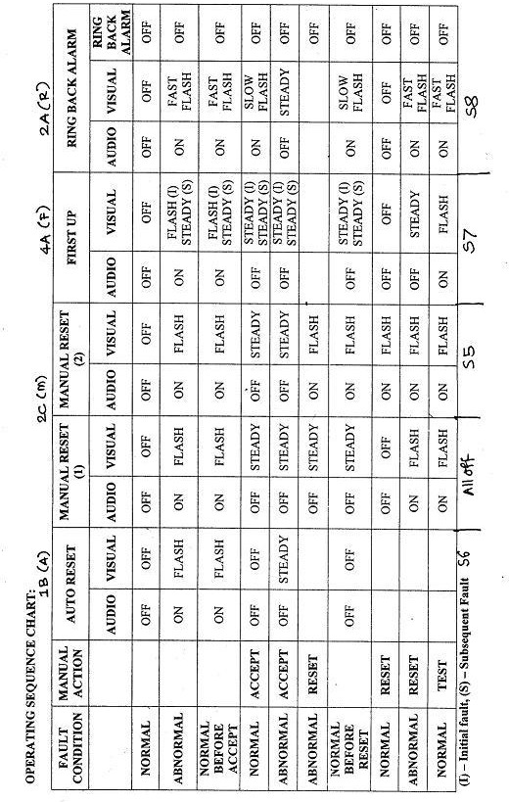

**Screenshots of the Tasks completed on the Virtual Lab:**

(Simulations results)

1. Introduction

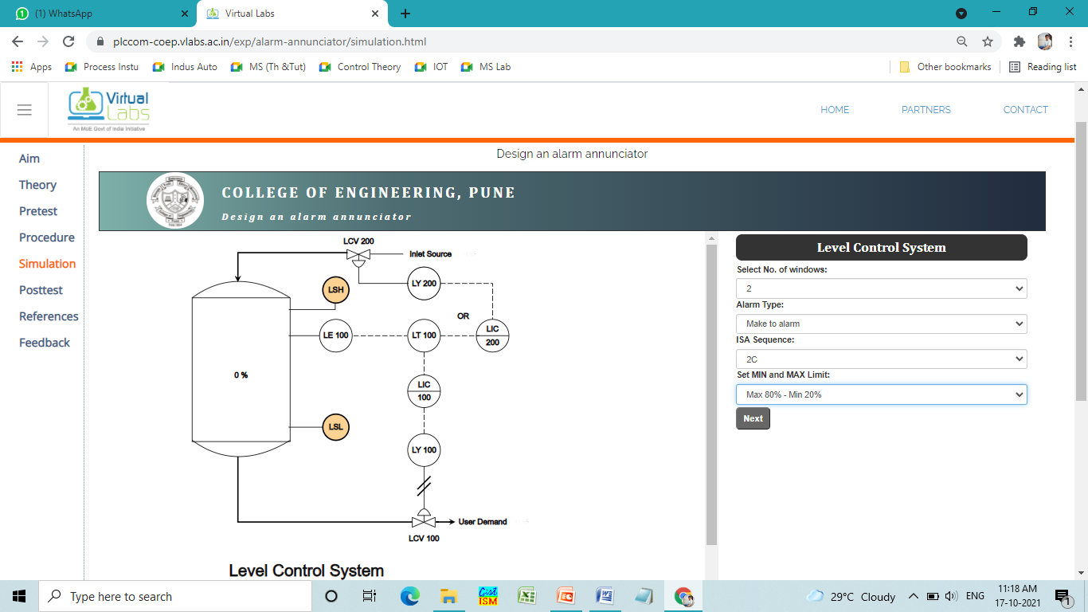

1. Circuit

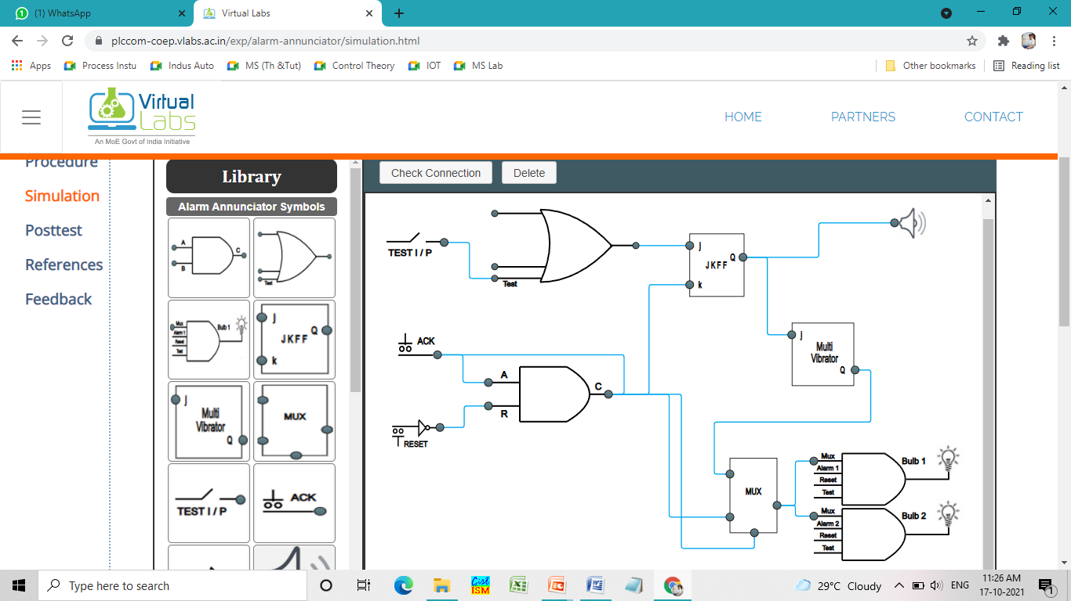

1. Testing of Alarm annunciator

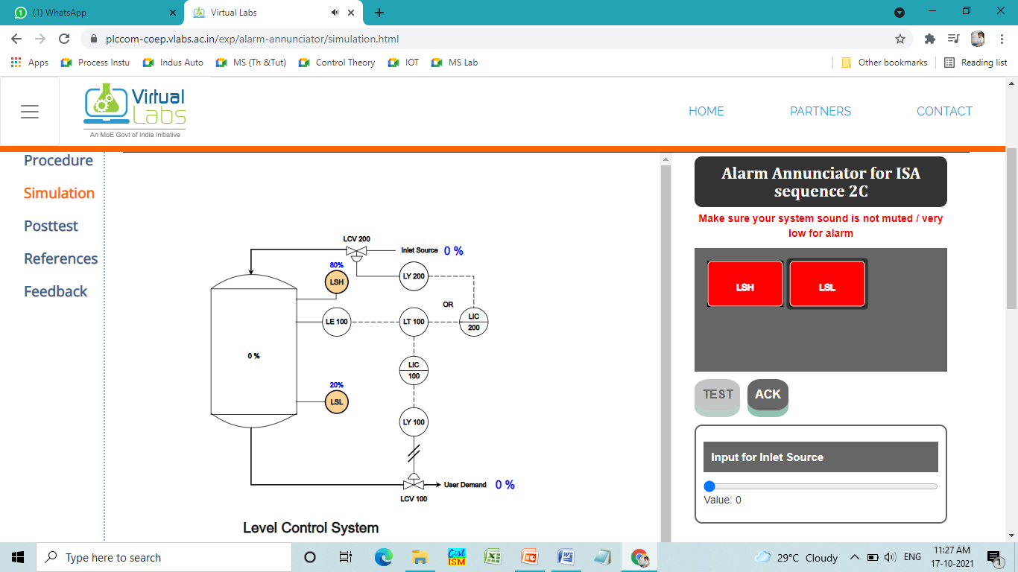

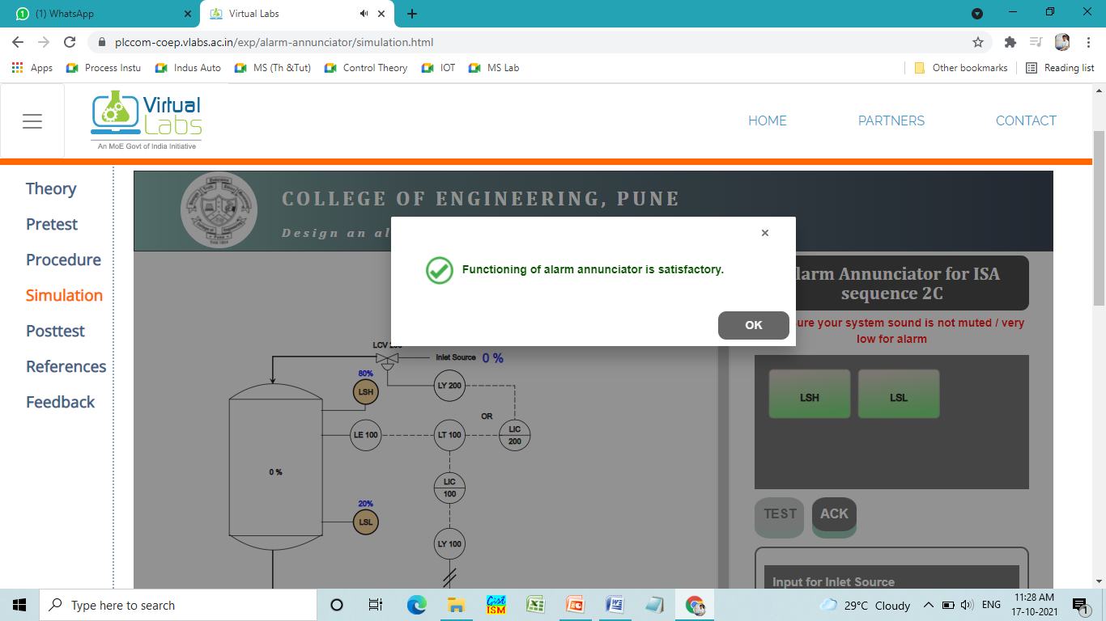

1. Fault Detection

